 

Assemblies from 6th Form and Further Education Colleges

PS@16 – The application process for Post 16 options. Sixth Form, Further Education Colleges and Apprenticeships

Ongoing support for developing Employability Skills

Ongoing Intentions and Destinations information to ensure you are certain of your Post 16 choices

Support from Internal and External Careers Teams on Results Day

Careers Fair – Held at Wigston College

PSHCE Careers Lessons

**A Levels** – Select 3 or 4 A Levels

**Grades Required:** Minimum of 5 GCSE’s Grades 5 and above

**Further Education –** A range of grades will be needed to enrol on the courses you are wanting to pursue. Check with in College for all entry requirements to ensure you gain a place on the course.

**Apprenticeships** – You earn and learn

**Grades Required:** GCSE x5 Grades 5 and above

**Ongoing Careers support from the Careers Team**

World Skills Show – Trip to the NEC Birmingham

CV Writing and Interview Skills with local employers. This will develop your skills for College and Job interviews

Career meetings: What am I doing Post 16?

**Year 11**



Ongoing Intentions and Destinations information to ensure you are on track for your Post 16 choices

Work Experience

Experience the world work

PSHCE – Careers session and how to start planning for Post GCSE’s options and your future

Careers Fairs and why they are important in your decision making

Careers Talks and why they are important in your decision making

Careers Fair – Held at Wigston College

World Skills Show – Trip to the NEC Birmingham

Ongoing support for developing Employability Skills

Career meetings: What am I doing for Work Experience and Post 16?

**Year 10**



Ongoing Intentions and Destinations information to ensure you are confident about your GCSE options and Career choices.

Careers meetings, supporting you in your decision making

Careers Fair – Held at Wigston College

Careers Talks and why they are important in your decision making

Work Shadowing. See what the world of work is like

**Year 9**

PSHCE – Careers sessions and how to start planning for choosing your GCSE’s and planning for Your Future

Support with selecting your GCSE Options

START – The Careers Programme. Is it up to date?

Ongoing support for developing Transferable and Employability Skills

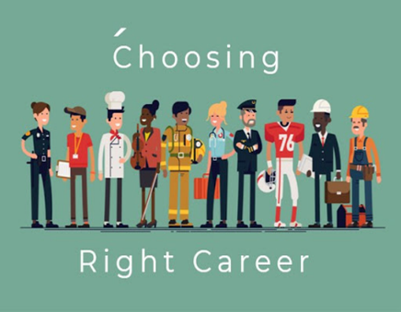

PSHCE – Careers sessions and how to start thinking about what career choices you are interested in. How are you going to get there?

Developing Transferable and Employability Skills

**Year 8**

An Enterprise Project with local businesses

Intentions and Destinations What are you thinking of doing when you leave school?

Introduction to 6th form Teams and Further Education colleges



Introduction to and start to use the careers online programme START

**Year 7**

Introducing Careers and what does it mean to me?

An Enterprise Project with Local businesses to develop an understanding of the world of work

An Enterprise Project with Local businesses to develop an understanding of the world of work



"I attribute my success to this - I never gave or took any excuse." — Florence Nightingale