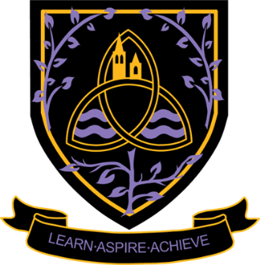

**Employment –** Straight into the world of work.

**Apprenticeships –** Earn whilst you learn. Furthering your skills set, whilst gaining experience and networking with people to secure your employment future

**University –** The course you have selected and focus your studies on.

Don’t forget to keep in contact and let us know how you are doing and what you are up to. Maybe you could come back and chat to the students and staff.



Careers meetings with internal and external careers teams

Continued support with UCAS Applications

Intentions and destinations. To help us to support you with your post 18 options

Access to local employers to help identify and develop skills required for the world of work

Careers networking with a wide range of local and national businesses

If University isn’t for you, support is given with apprenticeships and employment

Careers talks, trips and events to support your post 18 options

Life Skills lessons. Further enhancing your skills and knowledge for the world of work or University life

**Ongoing Careers support from the Careers Team**

**Year 13**



Careers meetings with internal and external careers teams

Intentions and destinations. To help us help you plan for your post 18 options

Work Experience. Gain access to employers and their networks

UCAS Applications. If you are wanting to experience University life.

**Year 12**

Life Skills Lessons. Enhancing your skills and knowledge for the world of work or University life

Increased Interactions with businesses through the careers networks



**Welcome to Wigston College**